**Lab Assignment: 09**

**Object:** To draw the ***Activity Diagram*** for ***Hotel Management.***

**Introduction:**

Activity diagram is another important diagram in UML to describe the dynamic aspects of the system. Activity diagrams are the object-oriented equivalent of flow charts and data-flow diagrams from structured development.

Activity diagrams describe the work flow behaviour of a system. The process flows in the system are captured in the activity diagram. It illustrates the dynamic nature of a system by modelling the flow of control from activity to activity.

**Elements of Activity Diagram:**

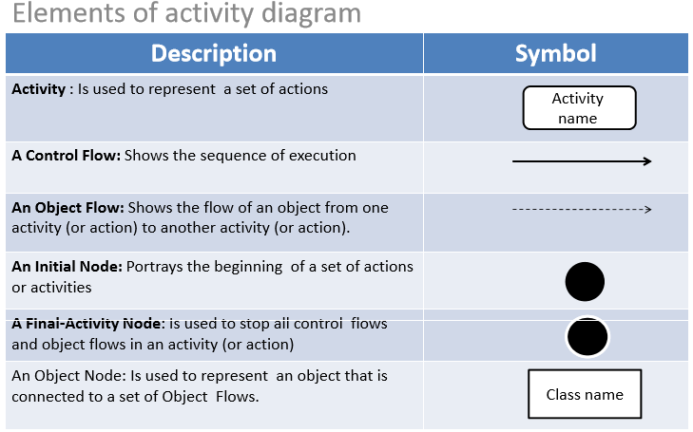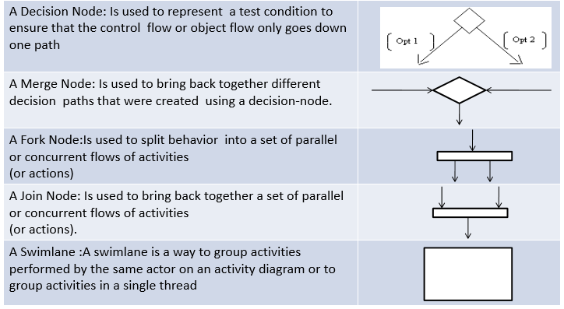

**When to Use Activity Diagrams?**

When we have to explore the logic of-

* a complex operation.
* a complex business rule.
* a single use case.
* several use cases.
* a business process.
* software processes.

*A typical example of Activity Diagram of Enrolment in University:*

